Country Results Report

The Biodiversity Finance Initiative (BIOFIN) Programme in Uzbekistan, Phase II

REPORTING PERIOD: January to December 2025

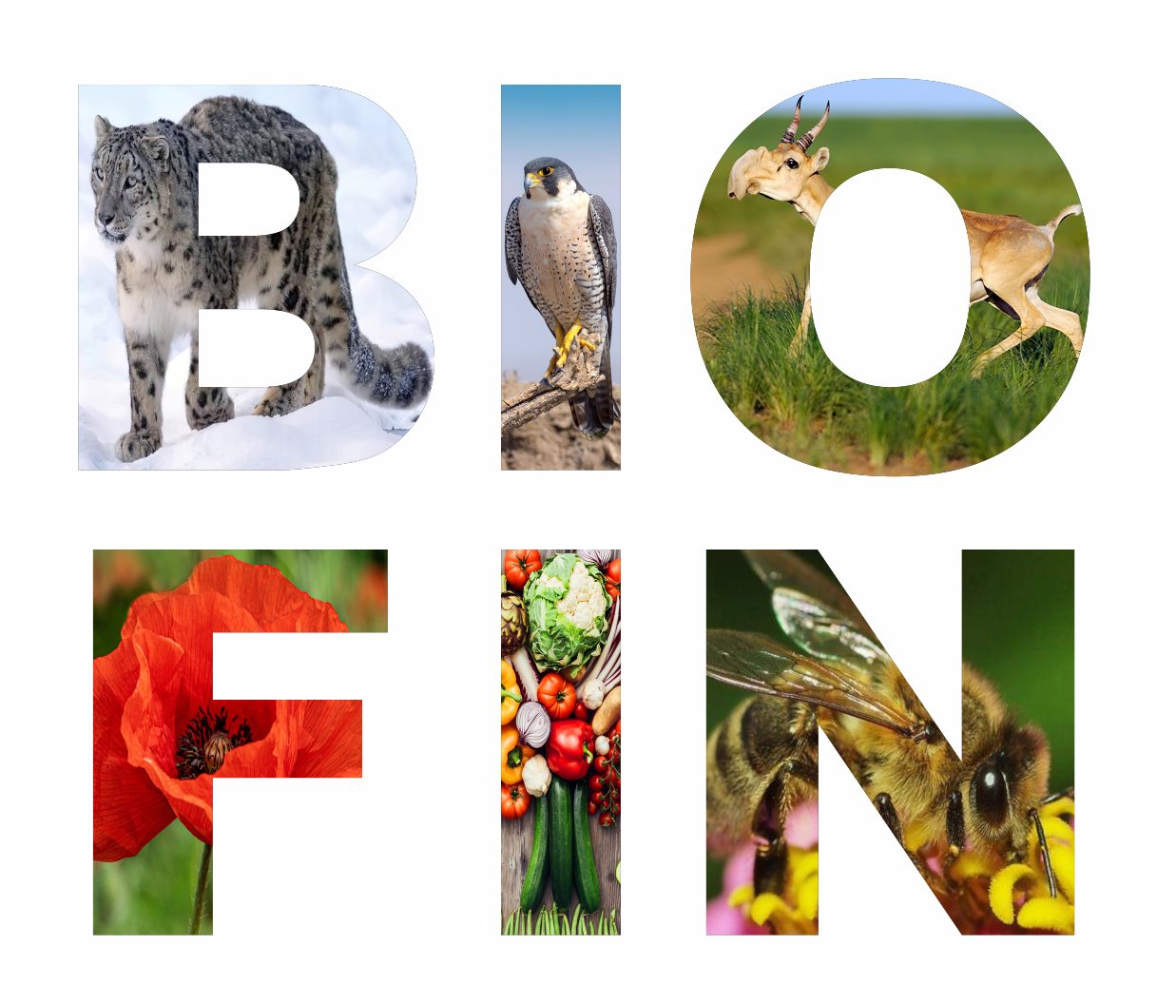
December 18, 2025

BIOFIN COUNTRY PROGRAMME PROFILE

Country: Uzbekistan

Programme period: June 2021 – December 2030

Budget: $324,000 (German Government)
$253,000 (Swiss Government)

Geographic profile:
Uzbekistan is located in the southwestern part of Central Asia and covers an area of 447,400 km² (about 44.9 million hectares), of which 425,400 km² (42.6 million hectares) or 95% is land (56th place in the world). The diversity of Uzbekistan's ecosystems includes deserts and semi-deserts (37.1 million hectares or almost 83% of the total area), mountains and foothills (5.2 million hectares or 13% of the land area), the Aral Sea, other rivers and water bodies, forests, etc. (Figure 1).

Biodiversity profile: The biodiversity of Uzbekistan includes about 20 thousand currently known species. Among them, higher vascular plants, mosses, lichens, fungi and algae number about 11 thousand species, representatives of the fauna - more than 15.6 thousand species. The endemism of higher vascular plants in Uzbekistan is about 8%. Relic endemics make up 10-12% of the total number of endemic species.
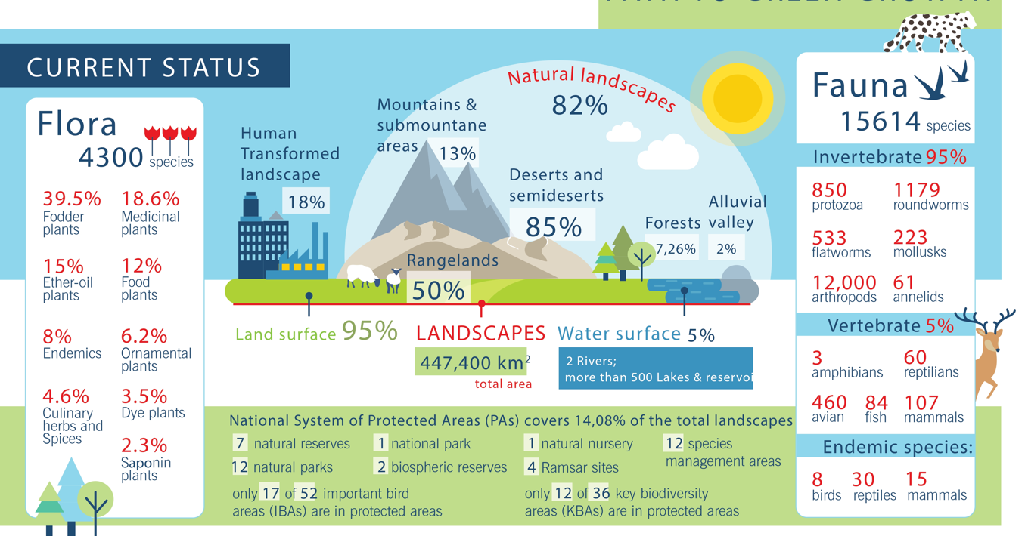
Figure 1: Country’s biodiversity profile

Acknowledgements
The Biodiversity Finance Initiative (BIOFIN) programme team in Uzbekistan is thankful to all partners – namely, Governments of Germany and Switzerland and the National Committee on Ecology and Climate Change, the Ministry of Economy and Finance, non-government and private sector – for their continuous support and assistance in making the implementation of BIOFIN in Uzbekistan possible.
This report is collaboratively authored by members of the programme team, with support from the BIOFIN global programme management team.

Table of Contents
Table of Contents 1
Abbreviations and Acronyms 2
Executive summary 3
A. Country factsheet: the country’s biodiversity finance profile and the programming approach 5
A.1. Biodiversity finance profile 8
A.2. National implementation context 9
B. Overview of key results 11
B.1. Key objective: produce a validated Biodiversity Finance Plan (BFP) 11
B.1.1. Output level activities and results (PIR>BER>FNA) 12
B.1.2. Notable developments toward, or away from, intermediate outcomes and finance outcomes 12
B.2. Implementation of Finance Solutions 13
B.2.1. Implementation of activities under “Academic Capacity Development” solution 13
B.2.2. Implementation of activities under the “Conservation Car License Plates” finance solution 13
B.2.3. Implementation of activities under the “Biodiverity Budget Tagging” finance solution 14
C. Social inclusion stories 14
D. Lessons learned and adaptative measures 14
E. Risks 16
E.1. Programmatic risks (risks to the programme) 16
E.2. Social and environmental risks (of the programme) 17
List of annexes and related notes 17
Annex 1: Indicator Tracking Table (in Excel) 17
Annex 2: BIOFIN Theory of Change 17

Abbreviations and Acronyms

BIOFIN | Biodiversity Finance Initiative
MoE | Ministry of Ecology, Environmental Protection and Climate Change
NCECC | National Committee on Ecology and Climate Change
MEF | Ministry of Economy and Finance
MWP | Multi-year Work Plan
AWP | Annual Work Plan
APA | Annual Plan of Actions
PIR | Biodiversity Finance Policy and Institutional Review
BER | Biodiversity Expenditures Review
FNA | Biodiversity Finance Needs Assessment
BFP | Biodiversity Finance Plan
FS | Finance Solutions
NBSAP | National Biodiversity Strategies and Action Plans
PB | Project Board
M&E | Monitoring and Evaluation
UNDP | United Nations Development Programme
UNDP CO | UNDP Country Office in Tashkent
ECA | Environment and Climate Action Cluster of the UNDP Country Office
GoU | Government of Uzbekistan
Fund | Fund for Ecology, Environmental Protection and Waste Management under the Ministry of Ecology, Environmental Protection and Climate Change
ODA | Official Development Assistance
ToC | Theory of Change
GGGI | Global Green Growth Institute
GLOBE | BIOFIN’s Global Biodiversity Expenditures Taxonomy

Executive summary

Progress toward targeted results
In 2025, BIOFIN Uzbekistan achieved major milestones, marking the transition from the methodology phase to implementation. The project finalized and validated the Biodiversity Finance Needs Assessment (FNA) and the Biodiversity Finance Plan (BFP) during the Project Board meeting on 28 February 2025. Together with the previously completed Policy and Institutional Review (PIR) and Biodiversity Expenditure Review (BER), these deliverables provide a comprehensive foundation for biodiversity finance reform in Uzbekistan.
The FNA identified a minimum funding gap of US$60 million to implement the National Biodiversity Strategy and Action Plan (NBSAP) through 2028. To address this, the BFP outlines 11 tailored finance solutions, including Biodiversity Budget Tagging, Conservation Car License Plates, Biodiversity Credits, and Payment for Ecosystem Services. Two priority solutions—Academic Capacity Development and Conservation Car License Plates—advanced significantly in 2025, with academic integration scheduled for launch in 2026 and advocacy efforts ongoing for license plate institutionalization.
Progress on Finance Solutions Implementation
In 2025, BIOFIN Uzbekistan advanced the implementation of key finance solutions outlined in the Biodiversity Finance Plan. Academic Capacity Development moved forward with the integration of BIOFIN methodology into the Master’s in Sustainable Finance program at Green University, scheduled for launch in 2026. Despite strong interest from the key national partner, the Conservation Car License Plates initiative faced challenges in engaging other key stakeholders, and efforts to secure their involvement continued throughout the reporting period. Additionally, groundwork for Biodiversity Budget Tagging began in coordination with national budgeting reforms, positioning it as a specialized component of the forthcoming Green Budget Tagging framework. These efforts mark a significant transition from planning to operationalization, reinforcing Uzbekistan’s commitment to innovative biodiversity finance solutions.
Policy and Institutional Developments
Uzbekistan introduced landmark reforms, including the Law on Environmental Expertise, Environmental Impact Assessment, and Strategic Environmental Assessment (January 2025) and Cabinet Resolution No. 31 on wildlife conservation. These measures strengthen transparency, digitalization, and participatory governance in environmental decision-making. Additionally, a major institutional restructuring created the National Committee on Ecology and Climate Change (NCECC) under the Presidential Administration, signaling heightened political commitment to ecological priorities.
Advocacy and Partnerships
BIOFIN Uzbekistan amplified its visibility through high-level events such as the CITES COP20 ministerial dialogue in Samarkand, the Eco Expo, and regional forums under the Central Asia Mammal Initiative (CAMI). These platforms showcased BIOFIN’s role in mobilizing innovative finance for biodiversity and fostering regional cooperation. Preparations for a Biodiversity Budget Tagging workshop and collaboration with the NBSAP revision project further position BIOFIN as a key partner in aligning national strategies with the Kunming-Montreal Global Biodiversity Framework.
Looking Ahead
The implementation phase will focus on operationalizing finance solutions, institutionalizing the BFP within national frameworks, and leveraging synergies with green finance initiatives such as Uzbekistan’s Eurobond issuances and National Green Taxonomy. Sustained stakeholder engagement and capacity building remain critical to overcoming interagency coordination challenges and ensuring long-term impact.
During the reporting period, the Government of Uzbekistan demonstrated significant progress in improving its environmental policy and institutional frameworks. Particularly, the Law "On Environmental Expertise, Environmental Impact Assessment and Strategic Environmental Assessment" aimed at ensuring transparency and openness in the field of environmental expertise has been approved in January 2025. This landmark legislation introduces a comprehensive digital platform for environmental assessments to improve transparency and operational efficiency while institutionalizing strategic environmental reviews for major government programs and urban development plans. The law establishes an independent expert council to enhance decision-making credibility and streamline approval processes for smaller-scale projects without compromising environmental safeguards. Notably, it mandates inclusive public engagement in environmental review processes, reflecting global standards of participatory governance.
Moreover, Uzbekistan's Cabinet of Ministers adopted Resolution No. 31 to enhance wildlife conservation through systematic biotechnical measures. The regulation establishes comprehensive procedures for habitat protection, species preservation, and sustainable hunting grounds management. Key measures include habitat restoration, artificial feeding systems, veterinary protection, and disaster response for wildlife. The resolution mandates annual planning with strict reporting requirements to environmental authorities by January 10. Implementation progress will be tracked through a national geoinformation database starting April 2025. These efforts aim to balance ecological protection with sustainable hunting and eco-tourism development. The framework incorporates adaptive approaches tailored to regional conditions while ensuring accountability through rigorous compliance standards. These reforms collectively reduce administrative burdens while strengthening ecological protections, showcasing Uzbekistan's commitment to modernizing its environmental management systems through policy innovation and institutional capacity building.
While these developments mark important progress, sustained efforts are needed to deliver measurable results. Deeper systemic reforms across policy and legislative frameworks will be essential for creating enduring change. BIOFIN remains committed to supporting these efforts through hands-on implementation of financial mechanisms that enhance funding flows to Uzbekistan's biodiversity sector

Country factsheet: the country’s biodiversity finance profile and the programming approach
Since 2017, Uzbekistan has pursued sweeping socio-economic reforms to attract investment and stimulate growth. However, this rapid development has intensified pressure on natural resources, with significant environmental consequences. Key sectors like agriculture, fisheries, and tourism directly impact biodiversity, while energy production, mining, and urban expansion further strain ecosystems. Compounding these pressures, climate change and rapid population growth (adding approximately one million residents yearly) have accelerated resource competition and environmental degradation.
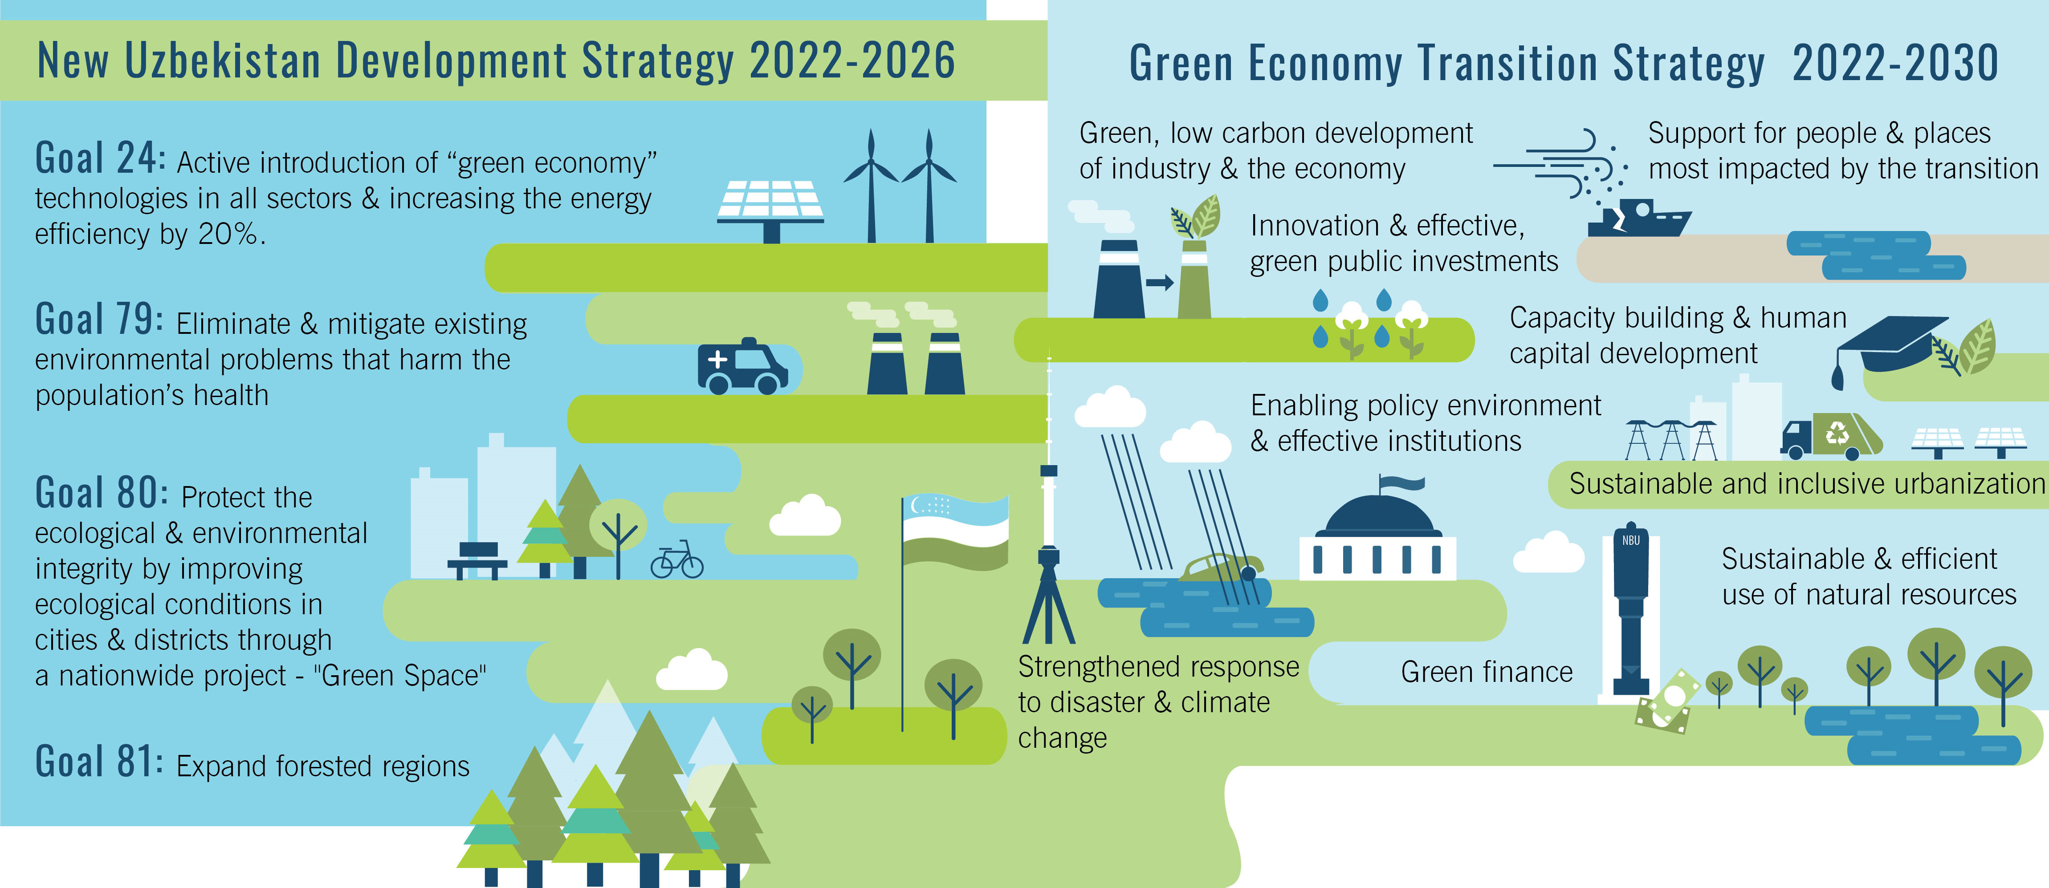
In response, the Government of Uzbekistan has prioritized climate and environmental policies to mitigate these challenges and promote sustainable development (see Figure 2).
Figure 2: Green policies and strategies
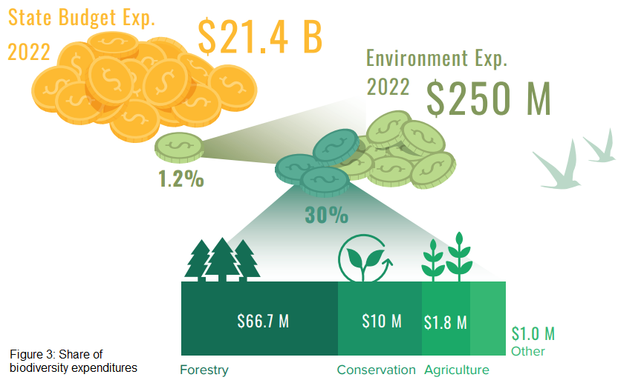
However, while major public investments go to climate mitigation projects mainly in the energy sector, biodiversity and ecosystems conservation remain a secondary priority with limited allocations from the state budget and are primarily funded by donors. For instance, the reviewed environment-related expenditures in 2020-2022 represented less than 1.21% (around US$ 260 million) of the overall public expenditures. The biodiversity-attributed direct expenditures made up an even smaller share not exceeding 0.33% of all state expenditures and were around US$ 70 million in 2022. Out of more than 30 environmental projects worth of US$ 563.2 million implemented by the donor community in Uzbekistan in 2017-2022, only 9 worth US$ 27.7 million were targeting biodiversity.
Uzbekistan has established itself as a regional leader in sustainable finance, pioneering the use of international debt instruments to fund its green transition. The country made history with its first US$235 million SDG Bonds in 2021, followed by a US$660 million Eurobond offering and a landmark UZS 4.25 trillion (US$330 million) green sovereign Eurobond listing on the London Stock Exchange in 2023. These innovative financial instruments are channeling funds into critical environmental projects, including water-saving technologies, sustainable urban transport systems, sanitation infrastructure, and protective forest plantations to combat erosion. Uzbekistan's successful bond issuances demonstrate strong international investor confidence in its sustainable development agenda and commitment to green growth.
In February 2025, Uzbekistan bolstered its commitment to sustainable development by issuing another €500 million (US$ 525 million) in 4-year green Eurobonds at a competitive 5.1% yield. The offering attracted strong investor demand, with orders reaching €1.6 billion in London. Proceeds will fund eco-friendly projects like water-saving technologies and sanitation infrastructure, with allocations to be disclosed in an internationally compliant impact report. This marks progress from 2024's 3-year bonds (issued at 5.375%), demonstrating growing market confidence in Uzbekistan's green finance framework.
This progress has been made possible through the long-standing collaboration between UNDP and the Government of Uzbekistan, which began in March 2021 and expanded in 2022 with the signing of a Memorandum of Understanding. This agreement focuses on aligning Eurobond issuance with Sustainable Development Goals (SDGs) and enhancing transparency and accountability for both the population and investors.
The joint efforts have led to the creation of an SDG Bond Framework, a comprehensive tool to maintain coherence across performance monitoring criteria and indicators used in various areas of public finance management. This framework integrates sustainability considerations into the public borrowing process and provides technical support for SDG bond and green sovereign bond issuance. Additionally, UNDP has supported the government by developing impact measurement methodologies, conducting impact monitoring, strengthening institutions, and providing training for line ministries.
These efforts culminated in the development and adoption of a first draft of National Green Taxonomy, a key task in the Action Plan for transitioning to a green economy and ensuring green growth in Uzbekistan until 2030. The approved National Taxonomy of the Green Economy defines categories and compliance criteria based on the classification of green activities. Notably, the conservation and restoration of biodiversity and ecosystems are included under category #3: “Sustainable agriculture, forestry, and ecotourism.” BIOFIN could help further enhance the National Taxonomy by focusing on nature-based solutions and activities that improve financial flows into biodiversity conservation and ecosystem restoration. The adopted Taxonomy will serve as a guiding document for the government in using proceeds from GSS-bonds and other sustainable financing. The Ministry of Economy and Finance is the executive body responsible for its implementation.
The National Agency for Prospective Projects (NAPP), which regulates Uzbekistan's securities market, was tasked with developing a methodological manual for issuing and circulating GSS bonds in the private sector. In early June 2024, NAPP amended the securities issuance regulations, focusing on "green" bonds. The revised regulations now include criteria for issuing corporate bonds aimed at green economy projects.
Private and public companies issuing green bonds must declare the intended use of funds, aligning with National Green Taxonomy criteria, and define Key Performance Indicators (KPIs) to measure project impact. Applicants must submit a comprehensive package, including a certificate of alignment with green taxonomy standards, signed by company management and the chief accountant, a bond issuance plan framework, and a compliance certificate. The compliance certificate must be issued by an organization authorized by the International Capital Markets Association (ICMA), approved by the Climate Bonds Initiative (CBI), and registered with the European Securities and Markets Authority (ESMA).
Shortly after these regulatory improvements, in October 2024 Uzbekistan’s Agrobank succeeded in issuing a US$ 455 million corporate Green Eurobond on the London Stock Exchange with GGGI’s technical support. This was Agrobank’s first Green Eurobond that had an oversubscription of US$ 1.1 billion, reflecting the growing international confidence in Uzbekistan’s capital markets.
Uzbekistan’s recent credit rating upgrade by Fitch Ratings to "BB" (Stable Outlook) in June 2025, followed by Citigroup’s high-level visit to Uzbekistan and announcement of plans to establish a local representative office in Tashkent, further demonstrates strengthening investor trust in the country’s market potential.
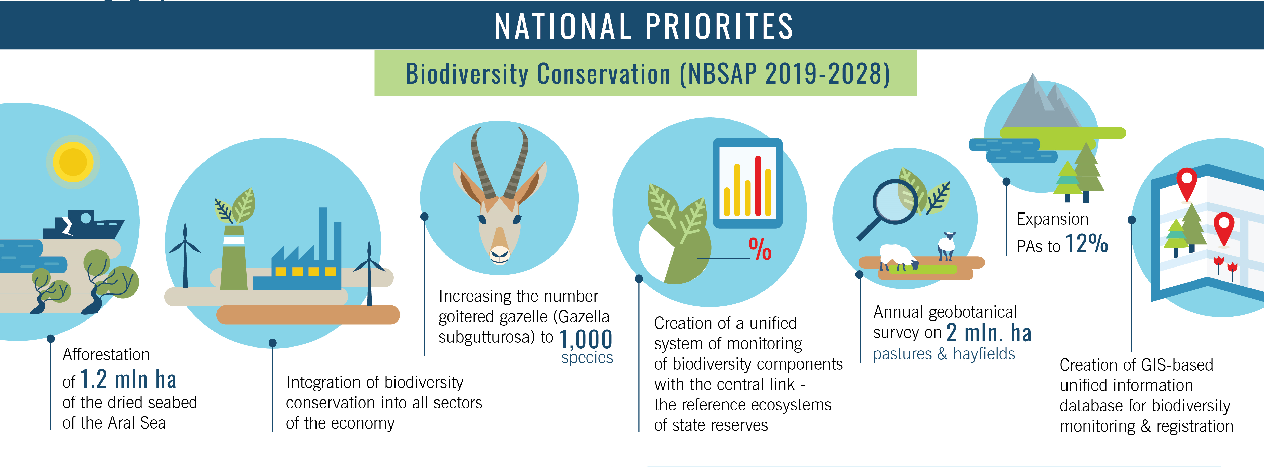
Uzbekistan’s current National Biodiversity Strategy and Action Plan (NBSAP), adopted in 2019, outlines biodiversity conservation targets through 2028 (Figure 4). The strategy combines innovative approaches—such as integrating biodiversity into sectoral policies and establishing a unified GIS-based monitoring system—with traditional conservation goals like expanding protected areas and protecting endangered species. However, insufficient progress on reporting has hindered a clear assessment of both implementation effectiveness and the adequacy of financial resources allocated to NBSAP.
Figure 4: Current national biodiversity priorities
Uzbekistan joined international consensus by adopting the Kunming-Montreal Global Biodiversity Framework (GBF) during CBD COP15, committing to align its National Biodiversity Strategy and Action Plan (NBSAP) with the GBF targets. Through the GEF's Early Action Support project initiated in April 2023, Uzbekistan revised national biodiversity targets that were formally presented at CBD COP16 in Cali. The country now faces an important deadline to complete its NBSAP update before CBD COP17 in 2026.
National biodiversity experts emphasize the urgency of initiating this revision process promptly. They highlight that accelerated action will position Uzbekistan to better access growing international funding opportunities emerging from GBF implementation. The timely NBSAP update is seen as crucial for channeling these resources effectively towards national biodiversity conservation priorities.
Recognizing the overlapping financial objectives between the GBF Early Action Support project and BIOFIN initiative, close collaboration between both teams proved essential. This strategic coordination served two primary purposes: preventing redundant work and systematically incorporating the GBF project's outcomes into BIOFIN's core deliverables.
As part of this integrated approach, the BIOFIN team conducted a thorough comparative analysis between existing NBSAP targets and the newly established national GBF targets during the finalization of the Financial Needs Assessment (FNA) and preparation of the Biodiversity Finance Plan (BFP). This harmonization process successfully pinpointed financing shortfalls relative to the updated GBF objectives while guaranteeing that financial mechanisms proposed in the BFP would effectively underpin forthcoming NBSAP updates.
In November 2025, a significant institutional reform was introduced in Uzbekistan in response to mounting public concern over the country’s escalating air pollution crisis. With Tashkent consistently ranking among the most polluted cities globally according to the Air Quality Index (AQI), the President of Uzbekistan mandated a major restructuring to strengthen the nation’s capacity to address urgent environmental challenges.
As part of this institutional reform, the Ministry of Ecology, Environmental Protection and Climate Change was removed from the Cabinet of Ministers and reorganized into the National Committee on Ecology and Climate Change (NCECC). The Committee was placed under the direct authority of the President, with the former Minister of Ecology appointed as Advisor to the President of the Republic of Uzbekistan on Environmental Issues and concurrently serving as Chairman of the NCECC.
The newly established NCECC has been vested with broad powers to enforce ecological legislation across all sectors of Uzbekistan’s rapidly growing economy, aiming to mitigate environmental and climate-related impacts. Notably, the Committee has been granted law-enforcement capacity through the creation of the Ecologic Police (Eco-Police), authorized to use force where necessary. The Eco-Police operates under the supervision of the Presidential Advisor and reports directly to the Head of the Presidential Administration.
The Presidential Decree establishing the NCECC also outlines its organizational structure, mandates, and priority initiatives. Among these is a flagship national program “Bio-Heritage”, designed to safeguard biodiversity and natural ecosystems for the benefit of future generations.

Biodiversity finance profile

Uzbekistan has been reforming its public finance system by transitioning to medium-term (currently annual) and results-based budgeting. These reforms seek to strengthen budget accountability, improve reporting, and promote transparency ("budget for citizens"). A key milestone was the 2023 adoption of the Program-based Budgeting Statute under the "Uzbekistan-2030" strategy. While green budgeting principles like nature-positive expenditure tagging remain unimplemented, they are currently under government consideration.
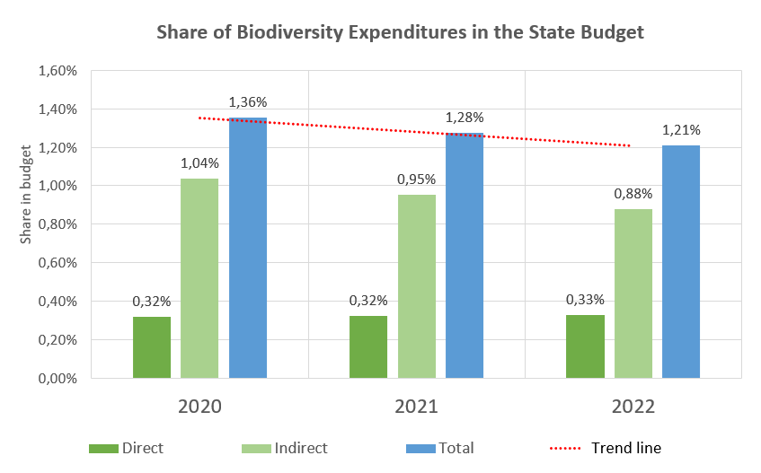
BIOFIN's analysis showed that biodiversity financing in Uzbekistan represents only a minor share of total environmental expenditures, with most funds channeled through the Ministry of Ecology. The Ministry manages the sole dedicated financial mechanism for biodiversity—the Fund for Ecology, Environmental Protection and Waste Management—which generates limited revenues from statutory environmental payments, violation fines, and environmental damage compensation.
Figure 5
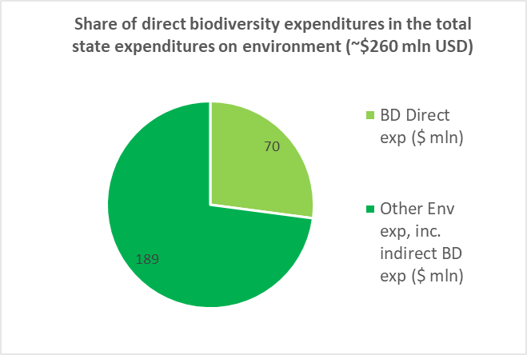
Environment-related expenditures constitute less than 1.21% (around $260 million) of the overall public expenditures (around $15.5 billion) in Uzbekistan (Figure 5). The direct expenditures attributed to biodiversity make up an even smaller share that does not exceed 0.33% of all annual state expenditures and was around $70 million in 2022 (Figure 6).
Figure 6
Private sector financing for biodiversity in Uzbekistan is minimal or non-existent due to the lack of an enabling environment. Uzbekistan is just beginning to introduce tangible and effective incentives for the private sector. Currently, there is no legislation or fiscal policy that encourages local businesses to voluntarily integrate ESG standards into their operations.

National implementation context

As Uzbekistan’s long-term partner in public finance reform, UNDP is implementing its Financing for Sustainable Development project to help establish an Integrated National Financing Framework (INFF). This initiative supports SDG-aligned development planning by mobilizing public and private financing while providing policy research and capacity building to strengthen economic, environmental, and social outcomes.
A core focus has been aligning national budgeting with SDG implementation. With UNDP’s technical support, Uzbekistan developed a Climate Budget Tagging (CBT) system, which revealed in the 2023 Citizen’s Budget that 11% of expenditures supported climate outcomes (primarily adaptation), while <0.5% had negative climate impacts. Recognizing the broader environmental dimensions of the SDGs, the government now seeks to expand CBT into a comprehensive Green Budget Tagging (GBT) framework.
Biodiversity Budget Tagging (BBT) will be a specialized component of GBT, building on Uzbekistan’s existing CBT methodology. To ensure coherence, BIOFIN’s national team will collaborate with other UNDP sustainable finance projects, preparing to advance BBT and use of GLOBE Taxonomy once GBT undergoes pilot testing in 2025.
Uzbekistan joined the BIOFIN Initiative in 2021. The BIOFIN activities are aligned with the following outcomes and outputs of the UNDP Country Programme Document for Uzbekistan for 2021-2025:
Outcome 5: By 2025, most at-risk regions and communities of Uzbekistan are more resilient to climate change and disasters, and benefit from increasingly sustainable and gender-sensitive efficient management of natural resources and infrastructure, robust climate action, inclusive environmental governance and protection.
Output 5.2: By 2025, national and local capacities are enhanced to implement green sustainable policies on the conservation and use of terrestrial and water ecosystems, environmentally sound management of chemicals and waste in line with international obligations.
Consequently, the “Biodiversity Finance Initiative (BIOFIN) – Phase II” project in Uzbekistan aims to strengthen the biodiversity governance framework by systematically measuring current expenditures, evaluating future financial requirements, and developing strategic plans for sustainable financing solutions. These efforts focus on scaling up funding, minimizing harmful expenditures, and enhancing the overall efficiency and effectiveness of biodiversity management.
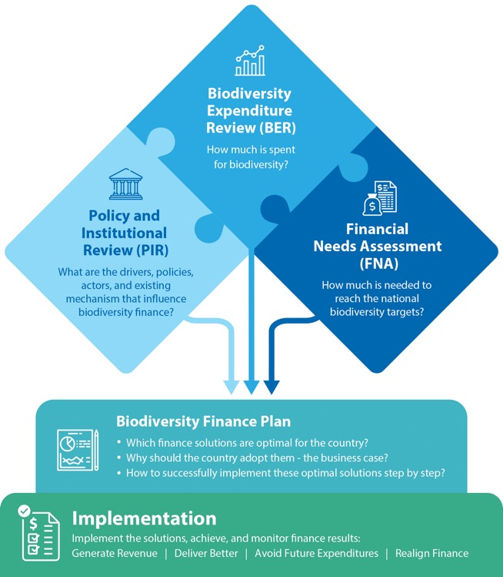
More specifically, the project is in line with Uzbekistan’s commitments under the CBD and Aichi targets that are included in the current NBSAP (national biodiversity conservation targets covered by adequate sustainably managed funds and biodiversity values integrated into national and local development and poverty reduction strategies and planning processes). With new GBF-based national targets and expected NBSAP revision, BIOFIN will continue playing a key advising role to help national policymakers take informed decisions and ensure effective implementation of national commitments under the CBD.
Figure 7: BIOFIN methodology
The project aims to further assist in enhancing biodiversity finance policy framework and establish an effective system for funding biodiversity conservation and ecosystem protection from all sources. This being done through the implementation of the BIOFIN methodology, including the sequential analysis of relevant frameworks (Figure 7). The programming approach primarily focuses on fostering effective partnerships and coordination across the entire stakeholder landscape (Figure 8). The primary objective of the Programme is to develop and implement a comprehensive biodiversity finance plan to support the NBSAP and other national biodiversity conservation strategies.
To achieve this objective, the following outputs have been articulated in the BIOFIN Programme’s theory of change (Annex 2):
  - Enhanced stakeholder awareness of and will to act on biodiversity finance issues (capacities of key actors strengthened);
  - Biodiversity finance discussion and coordination mechanisms (incl. partnerships) are in place;
  - Data/market intelligence enhanced, knowledge products developed (incl. PIR, BER, FNA, BFP, feasibility studies, etc.);
  - Biodiversity finance solution mechanisms designed, developed, and proposed (FS-related docs drafted and submitted, e.g. best practices guides, legislative text, etc.)
More specifically, the project activities are aimed at delivering against the following key consecutive targets:
- amount and percentage of funds that are allocated and spent on biodiversity by the state budget/overall funding made to country identified (BER);
- the national biodiversity finance gap for all biodiversity levels and values identified (FNA); and
- finance solutions to fill the national finance gap on biodiversity are identified and assessed (BFP and FSs).
Designed to be implemented in coordination with the newly established NCECC (former Ministry of Ecology) and the Ministry of Economy and Finance, the project is to ensure participation of all other important stakeholders, including NGOs and private sector.
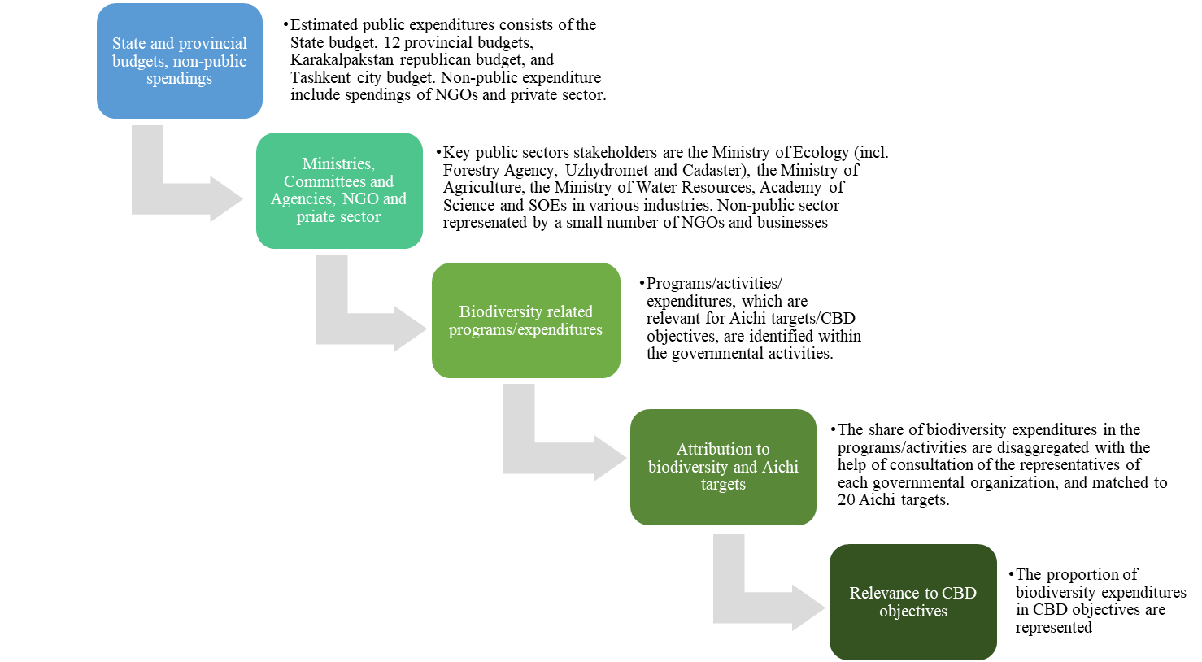
Figure 8. Conceptual framework for the BIOFIN work in Uzbekistan

Overview of key results

The sub-sections below outline the country program’s progress related to its targeted results. The progress towards the targeted results is measured using an Indicator Tracking Table (ITT) tool (Annex 1) that is developed based on the key result areas of the BIOFIN theory of change (Annex 2).

Key objective: produce a validated Biodiversity Finance Plan (BFP)

The BIOFIN programme in Uzbekistan aims to transform biodiversity financing by fostering an enabling environment for strategic investments across public and private sectors. By applying its proven methodology, the initiative develops and implements a validated Biodiversity Financial Plan (BFP) through collaborative solutions involving government, industry, and private partners.
During the reporting period, the project successfully completed its methodology phase in Uzbekistan, culminating in the country's inaugural BFP. This landmark document received formal validation and endorsement from stakeholders at the Project Board meeting held on February 28, 2025.
The newly developed BFP integrates insights from all prior BIOFIN-guided country frameworks analyses, offering a unified national strategy for biodiversity financing. Going beyond simple resource mobilization, this comprehensive framework engages public, private and civil society stakeholders through diverse financial solutions. The BFP outlines actionable strategies to enhance Uzbekistan's biodiversity financing mechanisms and meet national conservation targets.

Output level activities and results (PIR>BER>FNA)

Uzbekistan's biodiversity finance architecture has undergone substantial transformation following the launch of administrative reforms in 2023. In 2025, environmental reforms advanced amid escalating ecological challenges and mounting public discontent, which culminated during the winter heating season in severe air pollution crises. On the backdrop of increasing public pressure urging Government to take action to resolve the air pollution crises, a new Presidential Decree removed the Ministry of Ecology, Environmental Protection and Climate Change from the Cabinet of Ministers and restructured it into a National Committee on Ecology and Climate Change (NCECC). The Committee was placed under the direct authority of the President, with the former Minister of Ecology appointed as Advisor to the President of the Republic of Uzbekistan on Environmental Issues and concurrently serving as Chairman of the NCECC. The newly established NCECC has secured control over key structural agencies of the Ministry, including hydrometeorology, forestry, protected areas, waste management, and national climate change centre while tourism committee was separated into independent agency.
Following the completion of the PIR and BER reports in late 2023, the work on finalizing Biodiversity Financial Needs Assessment (FNA) continued in 2024 resulting in its verification by national partners during the last Project Board meeting on February 28, 2025.
The FNA process began in August 2023 with national stakeholder consultations. Due to challenges in sourcing data, the team developed an initial draft using available information and rough estimates, completing it by December 2023. However, the draft lacked accuracy due to non-expert assumptions. To enhance the quality and reliability of the analysis, the team re-engaged stakeholders in 2024 and produced a more comprehensive, NBSAP-aligned needs assessment.

Notable developments toward, or away from, intermediate outcomes and finance outcomes
Alongside the ongoing work on the Financial Needs Assessment (FNA), the development of Uzbekistan’s Biodiversity Finance Plan (BFP) was initiated in 2024. This process involved close collaboration with national stakeholders to identify, evaluate, and prioritize feasible finance solutions tailored to the country’s biodiversity goals. Through a series of consultations, technical reviews, and iterative refinements, a comprehensive first draft of the BFP was prepared.
The final version, reflecting consensus among all key stakeholders, was formally validated during the Project Board meeting held on February 28, 2025. The BFP outlines a below listed finalized set of biodiversity finance solutions selected for implementation in Uzbekistan, based on national priorities, institutional capacities:
- Blended Finance Facility: Exploring a combination of public and private financing mechanisms to support biodiversity conservation.
- Biodiversity Offsets: Developing mechanisms for compensating biodiversity loss through offsetting activities.
- Biodiversity Credits: An innovative financial solution to align economic development with ecological preservation.
- Repurposing Harmful Subsidies: Providing financial incentives to promote biodiversity-friendly practices in various sectors.
- Biodiversity Budget Tagging: Implementing a system to allocate specific budgetary resources for biodiversity-related initiatives.
- Conservation Car License Plates: Introducing special license plates for vehicles, with proceeds directed toward conservation efforts.
- Crowdfunding for forests and green projects: Creating e-platforms that help to raise donations from citizens and businesses and channel them to afforestation and greening urban spaces activities.
- PES (Payment for Ecosystem Services): Establishing a system where ecosystem service providers receive payments for maintaining ecological functions.
- REDD+ (Reducing Emissions from Deforestation and Forest Degradation): Leveraging international climate finance to incentivize forest conservation and sustainable land use practices.
- Nature or Biodiversity Bonds: A financial instrument that integrates debt refinancing, science, policy, and planning to help governments and communities protect biodiversity and enhance climate adaptation and mitigation.
- Academic Capacities Development. Institutionalization of the BIOFIN process through the integration of the BIOFIN Methodology into the curriculum of the Central Asian University of Environmental Studies and Climate Change (Green University) under the Ministry of Ecology.

Implementation of Finance Solutions

Implementation of activities under “Academic Capacity Development” solution

The project team has successfully established strong collaboration with the Central Asian University of Environmental Studies and Climate Change (Green University), ensuring government ownership and institutional commitment to the integration of the BIOFIN methodology into academic curricula. Recognizing the limited availability of national expertise in sustainable finance curriculum design, an international consultant was recruited to lead the development of a high‑quality academic module tailored to the Master’s in Sustainable Finance program. To complement this effort, two national consultants were engaged to contextualize the content and facilitate smooth operationalization within the newly established university. In parallel, the team initiated work on adapting the BIOFIN global MOOC e‑learning course for Uzbekistan, with plans to deliver it through the Presidential Academy of Public Service’s educational platform, thereby expanding access to finance‑for‑nature training for civil servants.
By the end of 2025, most of the key components of the academic module had been developed through close cooperation between the international consultants and local experts. Preparatory work continues into the first half of 2026, focusing on finalizing guidance materials, instructional frameworks, and conducting inception workshops and test lessons with newly designated lecturers. These activities are designed to ensure readiness and quality assurance before full launch. The academic module is scheduled to commence within the Sustainable Finance Master’s program in the fall semester of 2026, marking a significant milestone in institutionalizing biodiversity finance education in Uzbekistan and laying the foundation for long‑term capacity development in the sector.

Implementation of activities under the “Conservation Car License Plates” finance solution
The proposed finance solution, introducing conservation-themed car license plates, has been identified as a “low-hanging fruit” opportunity to mobilize new biodiversity funding while simultaneously raising public awareness. From the outset, the initiative attracted strong interest from the former Ministry of Ecology, now restructured into the National Committee on Ecology and Climate Change under the Presidential Administration. The Committee has expressed clear support and ownership of the project, recognizing its potential to generate up to US$ 2.5 million annually and fill a significant portion of the biodiversity financing gap. Early discussions confirmed the feasibility of the solution, and the project team has been actively engaging stakeholders to move the initiative forward.
Progress has, however, been tempered by challenges inherent in the intersectoral nature of the cooperation required. While the National Committee remains a committed beneficiary, the Ministry of Internal Affairs—responsible for technical implementation—has shown resistance, citing legal and operational complexities. As the Ministry of Internal Affairs traditionally prioritizes security over environmental concerns, additional time and effort will be needed to build its awareness and secure its engagement. Despite these hurdles, the project team continues to pursue implementation, leveraging the wide mandate and authority of the National Committee to ensure eventual full stakeholder ownership. The team remains confident that with sustained advocacy and coordination, the conservation license plate initiative could be institutionalized and operationalized in the country.

Implementation of activities under the “Biodiversity Budget Tagging” finance solution (additional activities with internal BIOFIN capacity)
The project team has actively engaged with the Government of Uzbekistan to explore the integration of Biodiversity Budget Tagging (BBT) within the country’s public finance system. Building on UNDP’s ongoing work to introduce Green Budget Tagging, biodiversity tagging has been proposed as a complementary component to strengthen environmental budgeting practices. This approach aims to enhance transparency and accountability in biodiversity-related expenditures and revenues, aligning with global best practices and national sustainability goals. To raise awareness among national stakeholders and international partners about BIOFIN’s capacities in this area, the project team, in collaboration with the BIOFIN global team, participated in the webinar “Integration of SDGs and Green Priorities into the Strategic Planning and Budgeting in Uzbekistan: Opportunities and Challenges” on December 18, 2025. The event, organized by UNDP’s Sustainable Development Finance Project and the Ministry of Economy and Finance, provided a platform to present BIOFIN’s tools and methodologies, including the Global Biodiversity Expenditure (GLOBE) Taxonomy.
The webinar gathered over 50 participants from government ministries, agencies, the private sector, research institutions, development partners, and IFIs, creating an opportunity to showcase BIOFIN’s achievements and practical instruments for biodiversity finance. The GLOBE Taxonomy was highlighted as a key tool for tagging biodiversity-related revenues and expenditures, analyzing financial gaps, and informing policy decisions to adopt innovative financing instruments. Moving forward, the project team plans to leverage this momentum by synergizing with the Sustainable Development Finance Project to incorporate biodiversity tagging methodology into the ongoing development of the Green Budget Tagging framework. This collaboration will ensure that biodiversity considerations are systematically integrated into Uzbekistan’s budgeting processes, ultimately supporting national biodiversity targets and contributing to global commitments under the Kunming-Montreal Global Biodiversity Framework.

Social inclusion stories

At present, the project does not have specific social inclusion cases to report. However, gender and social equity remain integral to its planning and implementation processes. The project is committed to addressing social inclusion by ensuring that the needs and perspectives of vulnerable groups—such as disadvantaged communities, women, and youth—are considered when evaluating and applying biodiversity finance solutions. To this end, the Terms of Reference (ToR) for the upcoming feasibility study will include an analysis of potential impacts on these groups, taking into account both opportunities and trade-offs. For instance, the project will assess how the BioCredit mechanism could help combat pasture degradation, generate green employment, alleviate pressure on ecosystems through improved pasture management, and promote women's empowerment.

Lessons learned and adaptative measures

In response to the dynamic and rapidly evolving policy and institutional landscape in Uzbekistan, the national BIOFIN project team has proactively adapted its approach to ensure continued progress and impact. Recognizing the challenges posed by shifting national priorities, the team placed strong emphasis on stakeholder engagement to raise awareness of BIOFIN’s relevance and its potential benefits for both government and private sector actors. A key adaptive measure included forging a strategic partnership with the National Climate Change Centre—an influential body operating under the National Climate Change Council chaired by the President. This collaboration has enabled closer alignment with national priorities and enhanced coordination in addressing climate and biodiversity finance challenges.
At the same time, the establishment of a Special Fund on Eliminating Urgent Ecological Problems under the newly created National Committee on Ecology and Climate Change offers the BIOFIN national team an opportunity to pursue designating this Fund as the national focal point for biodiversity finance. It further enables the formal adoption of the Biodiversity Finance Plan, developed by the BIOFIN team, as the Fund’s primary resource mobilization strategy, thereby securing its legal endorsement and institutionalization. The BIOFIN project team in Uzbekistan draws inspiration from other BIOFIN projects to optimize their results. Specifically, they are applying lessons from BIOFIN projects in Kazakhstan, Kyrgyzstan, and Mongolia, as well as from larger global initiative such as establishing Tiger Landscapes Investments Fund.
In the reporting period, the team continued sharing BIOFIN experiences and successes made on both regional and global scale with national partners and stakeholders. In particular, during the 3rd Range States Meeting of Central Asia Mammal Initiative (CAMI) under the UN Convention of Migratory Species (Bonn Convention) held on 24-26 June, 2025 in Tashkent, BIOFIN team was invited to present results of its work in Uzbekistan and make recommendations on specific financial solutions to be included in the CAMI’s 2026-2032 Programme of Work. During the event, team shared key findings from the BIOFIN process and Uzbekistan’s Biodiversity Finance Plan (BFP) and introduced the newly launched Tiger Landscapes Investments Fund (TLIF) as a potential model for developing similar blended finance mechanism for CAMI flagship species, such as the Snow Leopard.
Moreover, in June 2025, BIOFIN’s global and national work was showcased through interactive infographics and video clips at the inaugural Eco Expo, organized by the Government of Uzbekistan. Designed to become an annual international event, Eco Expo brings together stakeholders from the global green sector, including international organizations, government representatives, and businesses.
The national project team proudly positioned UNDP BIOFIN as a transformative initiative for Uzbekistan and the wider Central Asian region during the high-level ministerial dialogue held as a side event of COP20 CITES in Samarkand on November 23rd. The team presented BIOFIN’s regional and global achievements to Mr. Aziz Abdukhakimov, Advisor to the President of Uzbekistan on Environmental Issues and Chairman of the newly established National Committee on Ecology and Climate Change, as well as to senior officials from across Central Asia.
Through its poster exhibition, the team showcased BIOFIN’s decade-long expertise in developing nature-focused financial solutions. This advocacy emphasized how innovative financing approaches can close biodiversity funding gaps and strengthen national strategies for sustainable development. The strong engagement from high-level participants reaffirmed a shared understanding: advancing biodiversity finance is essential not only for Uzbekistan’s ecological resilience but also for fostering regional cooperation across Central Asia.
By championing BIOFIN, the national project team highlighted the urgency of mobilizing robust financial resources and innovative green mechanisms to safeguard biodiversity, ensuring that Uzbekistan and its neighbors can lead the way toward a sustainable and climate-resilient future. A strong collaboration and coordination mechanism has been established with the GEF-funded UNDP project focused on preparing the Seventh National Report and developing a new KM-GBF-based NBSAP. It has been agreed that the BIOFIN national team will provide technical support in costing the new Action Plan and in designing activities under National GBF Targets 18 and 19 for the upcoming NBSAP. Both teams concurred that the Biodiversity Finance Plan (BFP) for Uzbekistan, developed by the national BIOFIN team, serves as an excellent resource mobilization framework. This plan can be further refined to align with the new NBSAP and formally integrated as an essential component of the upcoming strategy, ensuring its official endorsement and institutionalization.

Risks

Programmatic risks (risks to the programme)

The main programmatic risks faced by BIOFIN Uzbekistan stem from the constantly changing national policy, institutional, and social context. Although the new administration remains popular, there is growing public resistance to the rapid shift toward a nature-positive economy—an approach that creates both beneficiaries and those who feel left behind. This tension may hinder the government's ability to sustain momentum on environmental and conservation initiatives.
The administrative reforms launched in early 2023 have brought both challenges and opportunities. Widespread restructuring of the public sector has disrupted program implementation due to frequent staff turnover, leading to gaps in continuity and institutional memory. However, the new government structure now includes dedicated units for integrating climate and environmental programs into sectoral planning. To be effective, this new generation of public officials will require targeted capacity-building support from development partners to strengthen their knowledge and skills.
BIOFIN stepped in to provide this kind of support and advance the biodiversity agenda in the public finance sector by designing a separate finance solution aimed at institutionalizing BIOFIN methodology. This will include the design and integration of an academic module into the curriculum of the Central Asian Green University, a recently established specialized educational institution under the NCECC (former Ministry of Ecology).
Another significant risk to the program's sustainability is the lack of effective interagency coordination. Efficient and reliable information exchange, free from bureaucratic delays, is crucial to achieving BIOFIN's objectives.

Table 1: Risk register for BIOFIN Uzbekistan
# | Description | Date Identified | Type | Impact &  Probability | Countermeasures / Mngt response | Owner | Submitted, updated by | Last Update | Status
1 | Lack of ownership and coordination on the side of national partners due to the fast changing political and institutional context (caused by ongoing administrative reform) | Feb 2023 | Political | P=5  I=5 | 1. National Climate Change Centre under the National Committee on Ecology and Climate Change has been informally appointed as BIOFIN’s key focal point  2. The emphasis on the need to improve stakeholder engagement has been given in the Decisions of the 2st Project Board meeting with participation of representatives of various stakeholders | M. Farrukh Sattarov, Director of the National Climate Change Centre | Mr. Tulkin Radjabov, National Project Coordinator | Dec 2025 | P=2  I=5
2 | Lack of local knowledge and research capacities to support quality studies under the BIOFIN methodology | Feb 2023 | Operational | P=4  I=4 | 1. Introduction and offering of the adapted BIOFIN MOOC online course through the Presidential Academy on Public Services  2. Implementing a FS that aim at introduction of the BIOFIN methodology at the academic institutions | Mr. Tulkin Radjabov, National Project Coordinator | Mr. Tulkin Radjabov, National Project Coordinator | Dec 2025 | P=1  I=1

Social and environmental risks (of the programme)

The BIOFIN country program does not introduce additional social and environmental risks. It aims to balance socio-economic and environmental benefits effectively. The program mitigates existing risks by incorporating UNDP’s principles for social and environmental sustainability (SESP) and aligns with Standard 1 of the project-level standards, specifically Biodiversity Conservation and Sustainable Natural Resource Management. All financial mechanisms developed under the project will focus on providing 'win-win' solutions that address a broad range of stakeholder interests.

List of annexes and related notes
The following annexes are included in this report:

Annex 1: Indicator Tracking Table (in Excel)
The Indicator Tracking Table provides an up-to-date snapshot (subject to the availability of related data) of progress made towards the BIOFIN country programme’s M&E indicator targets.

Annex 2: BIOFIN Theory of Change

